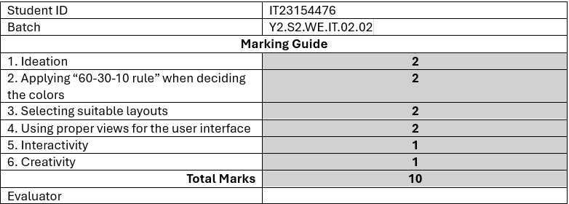
Description:

M Chocolate Shop – The Ultimate Online Chocolate Shopping Experience!
Indulge in the finest chocolates with M Chocolate Shop, your go-to mobile app for discovering and ordering premium chocolates effortlessly. Whether you're craving artisanal dark chocolate, creamy milk chocolate, or unique flavored treats, our app offers a curated selection to satisfy every sweet tooth.
With real-time inventory updates, customers can browse the latest collections and check product availability instantly, ensuring they never miss out on their favorite treats. The app’s intuitive interface allows users to filter chocolates by type, flavor, brand, and price—making it easier than ever to find the perfect selection for any occasion.

Screenshots:

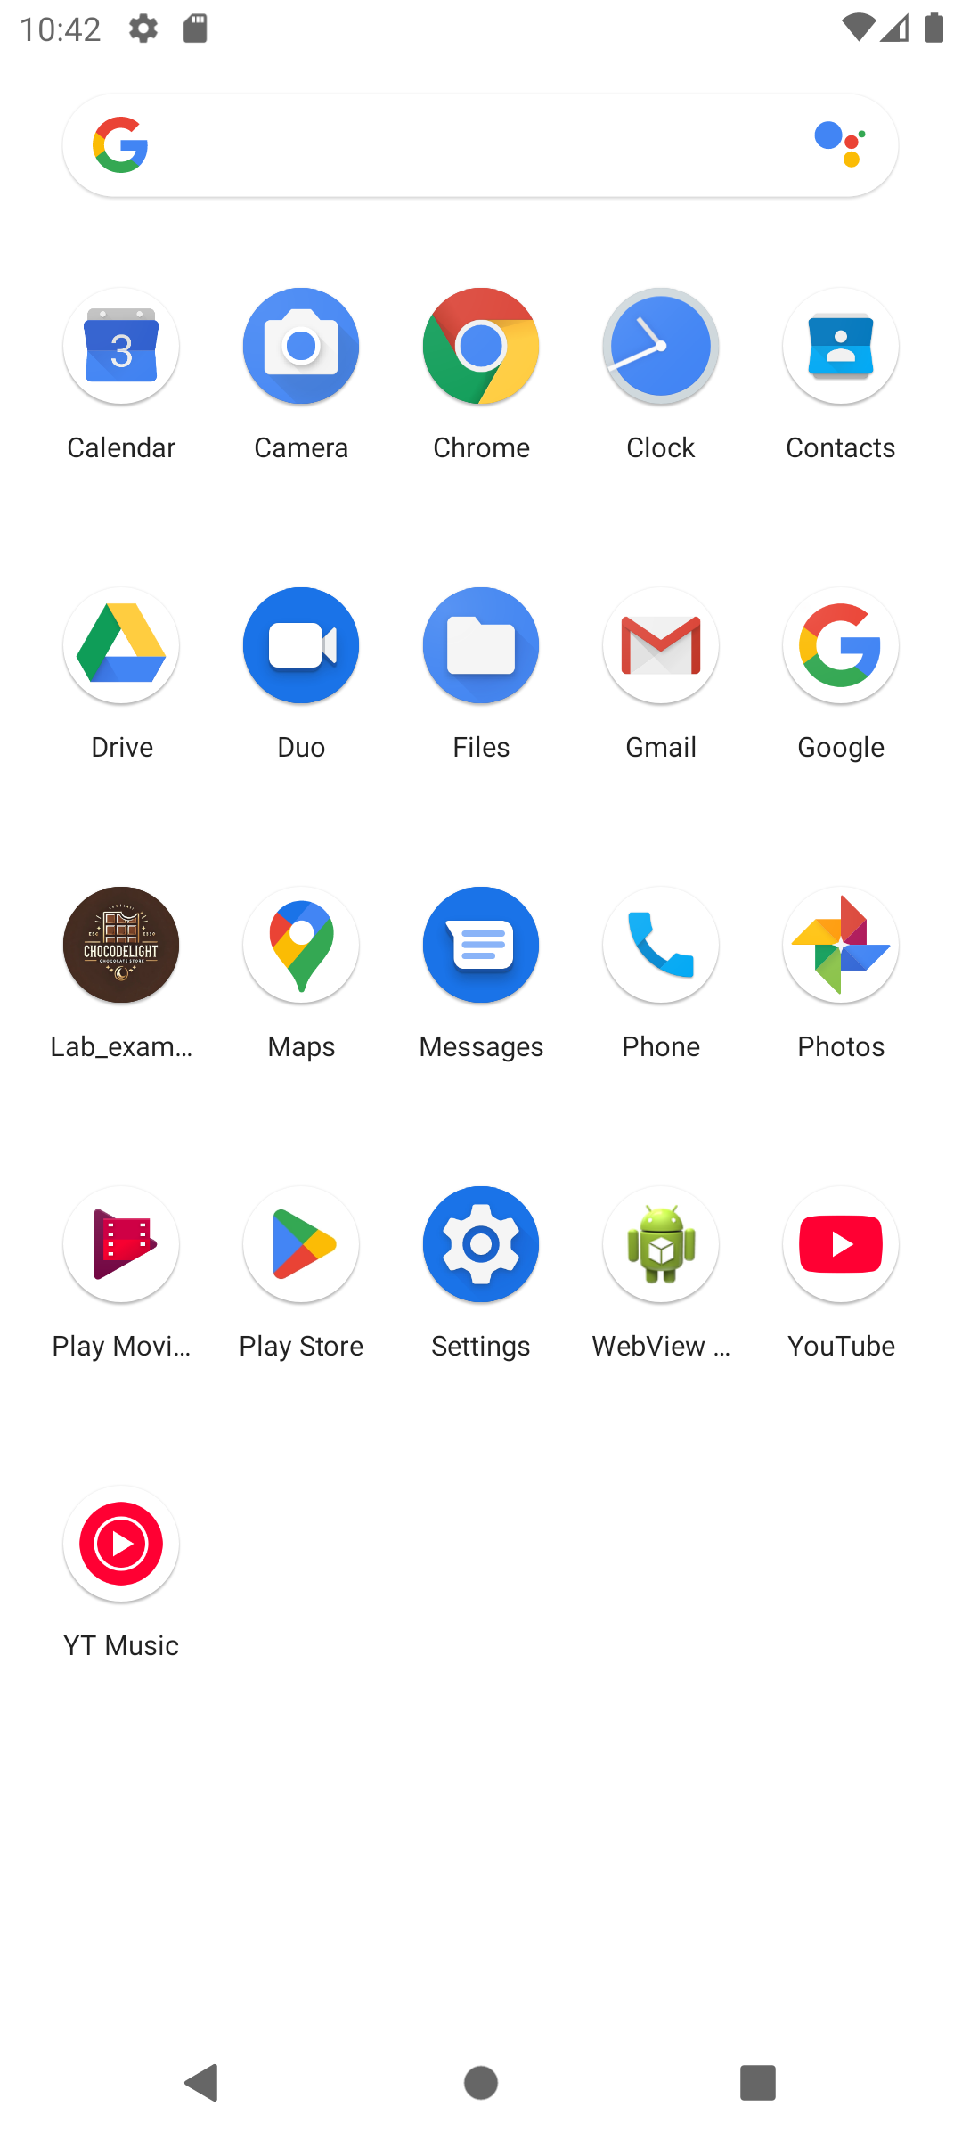
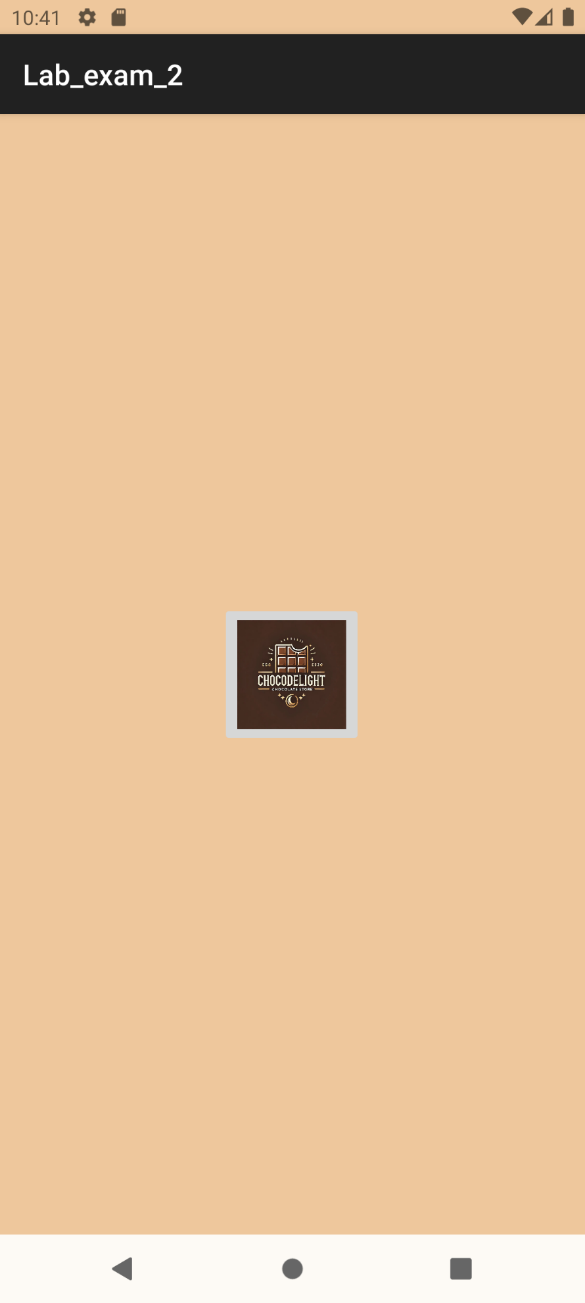
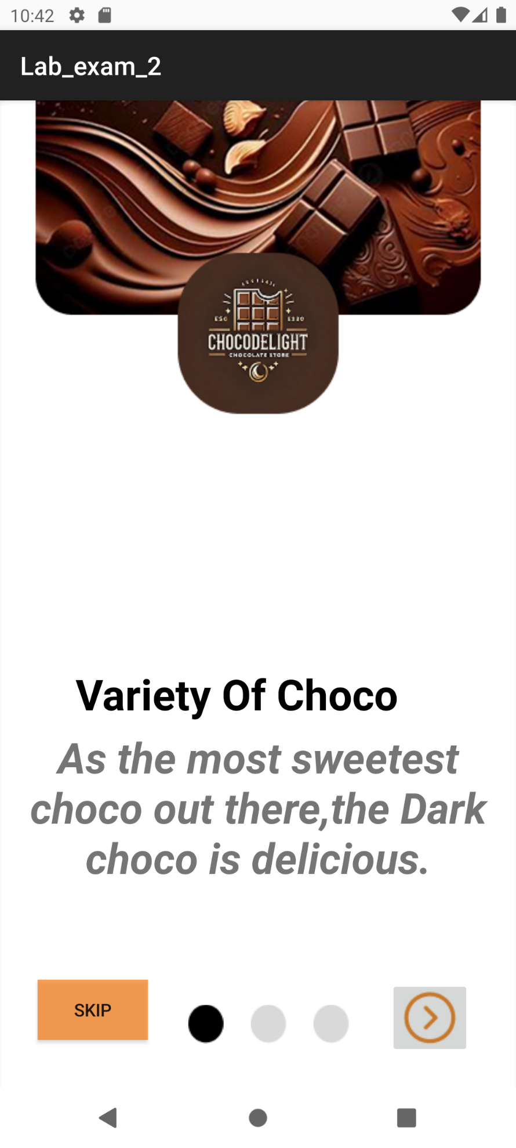
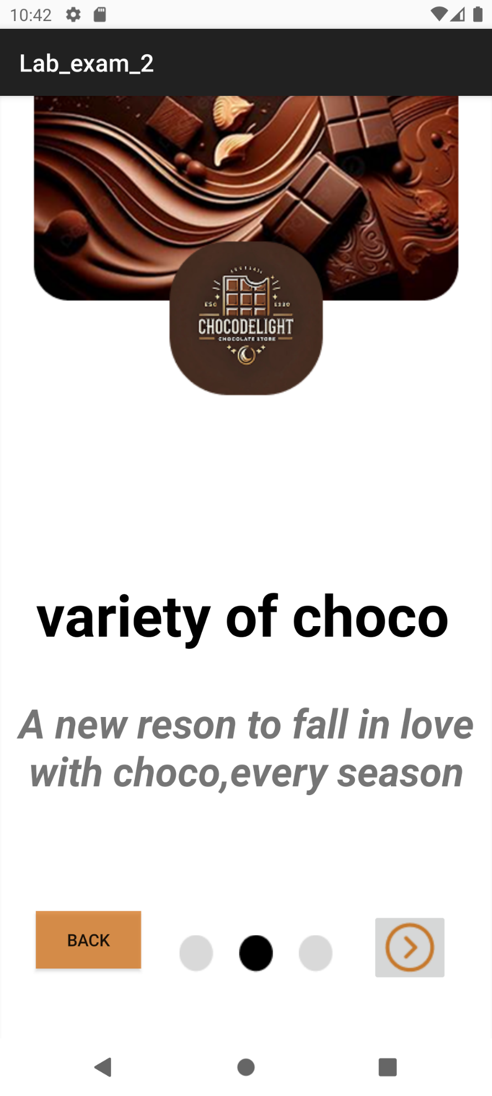
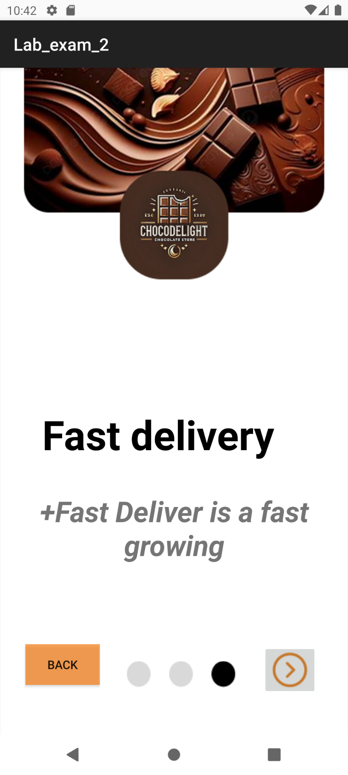
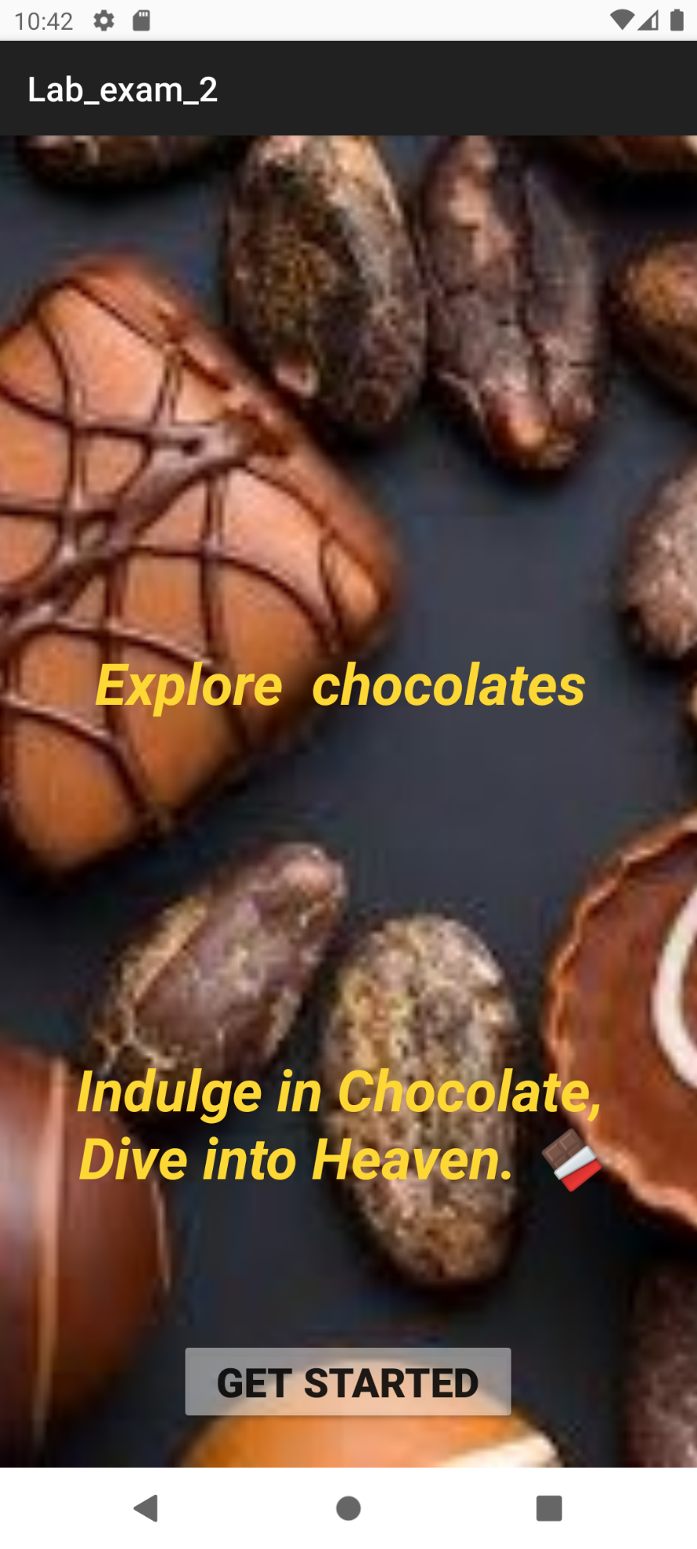
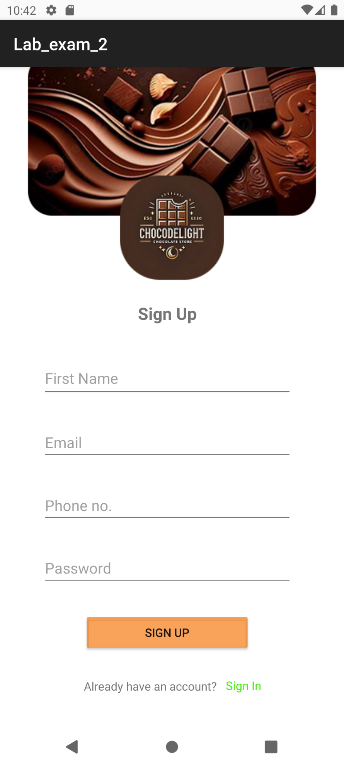
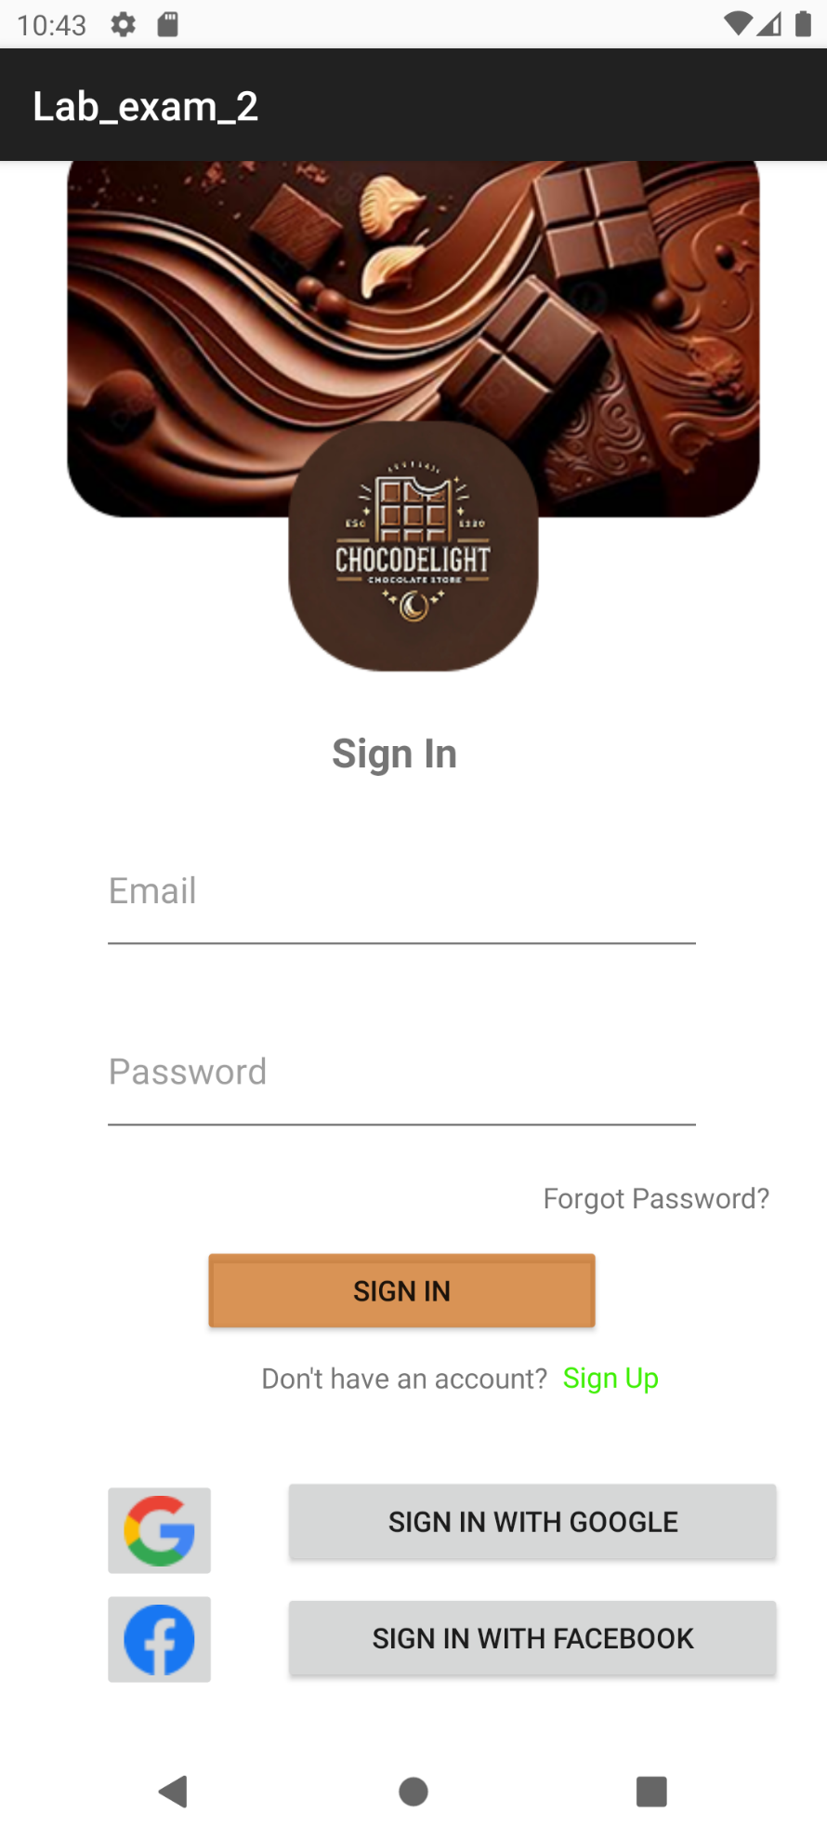
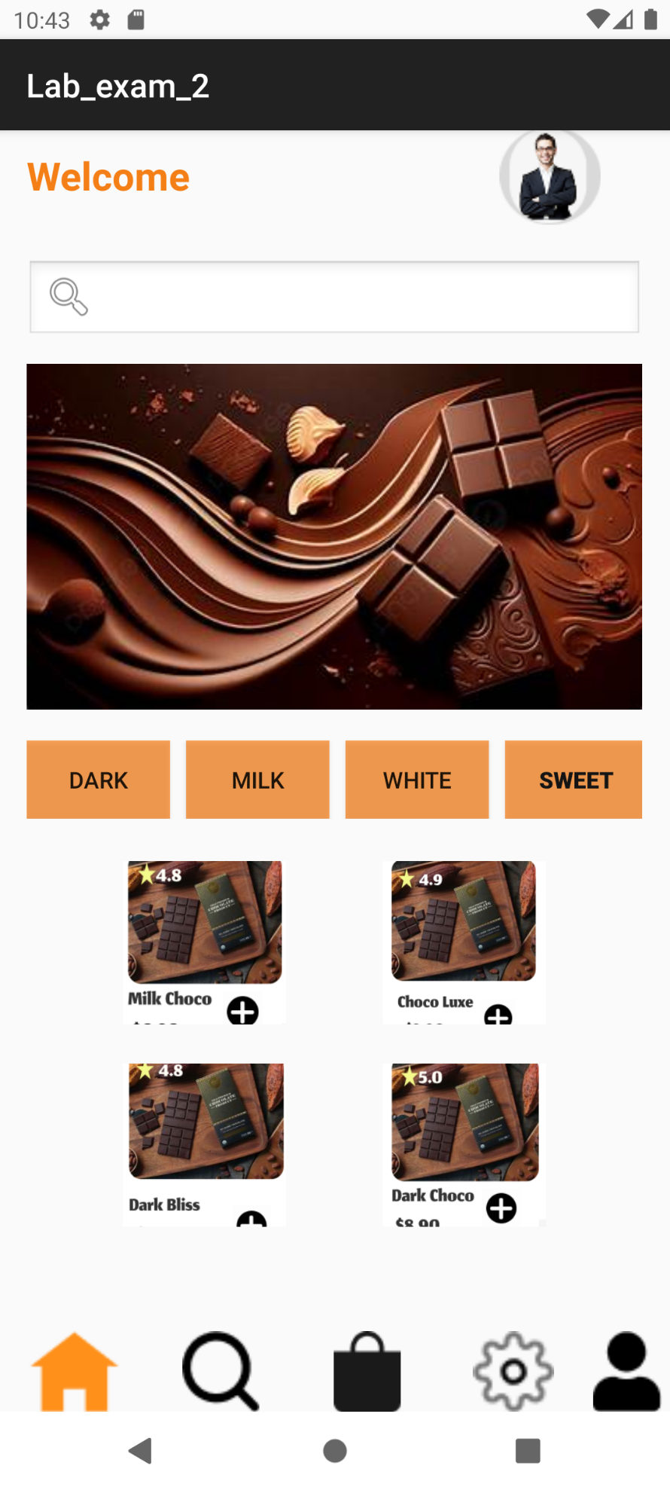
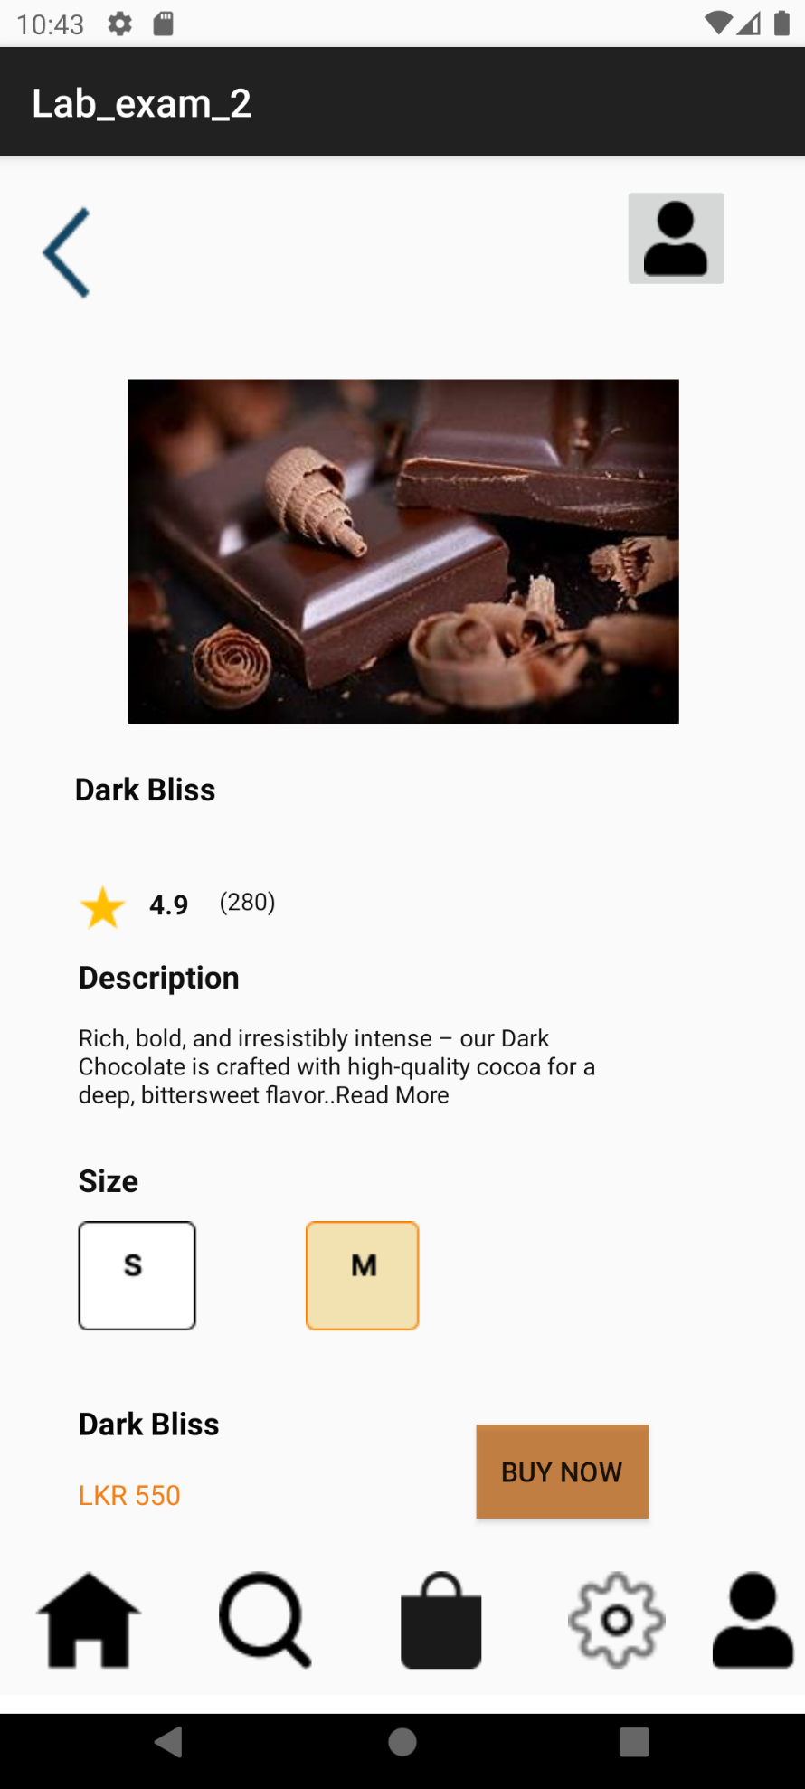
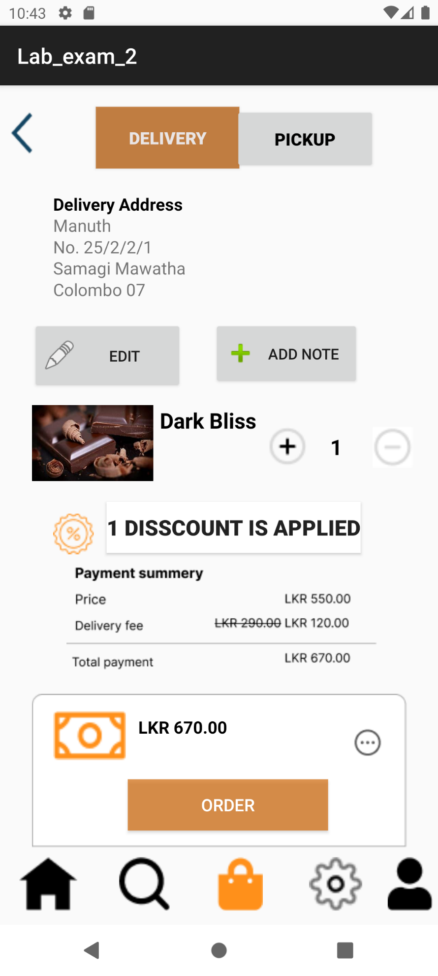
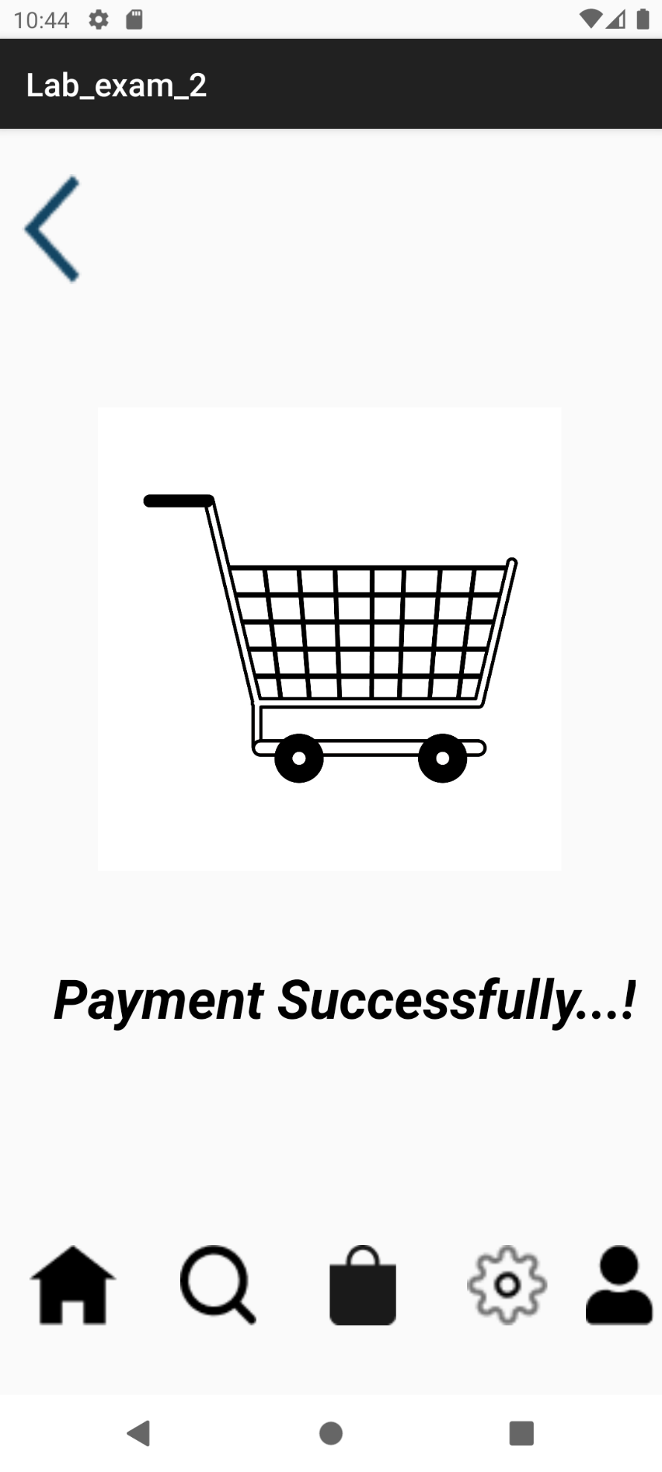
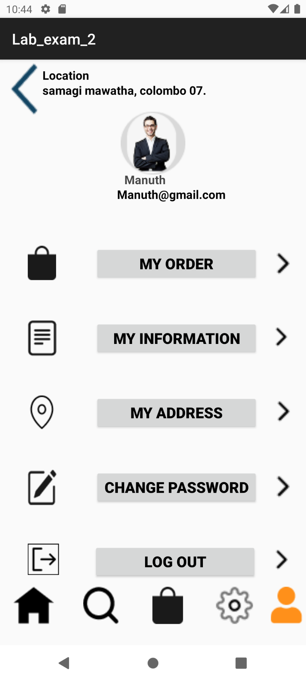
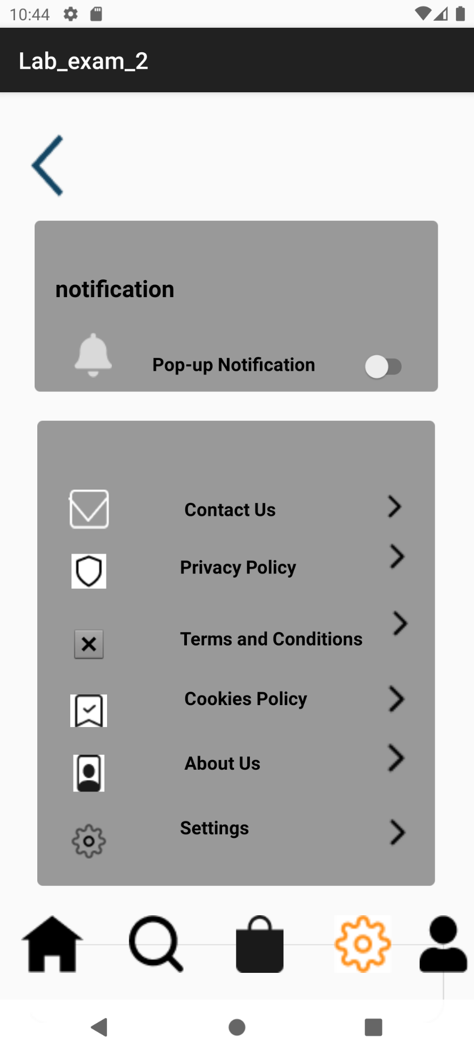

Content of xml files of Strings and Colors:
Strings
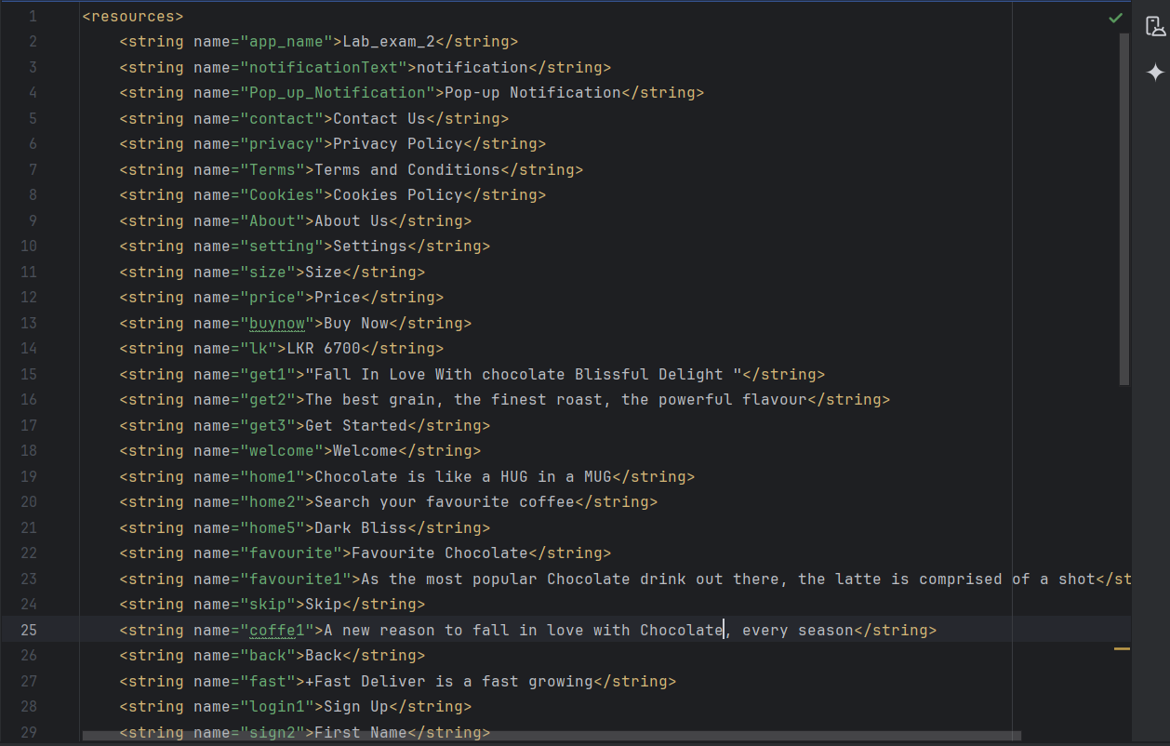

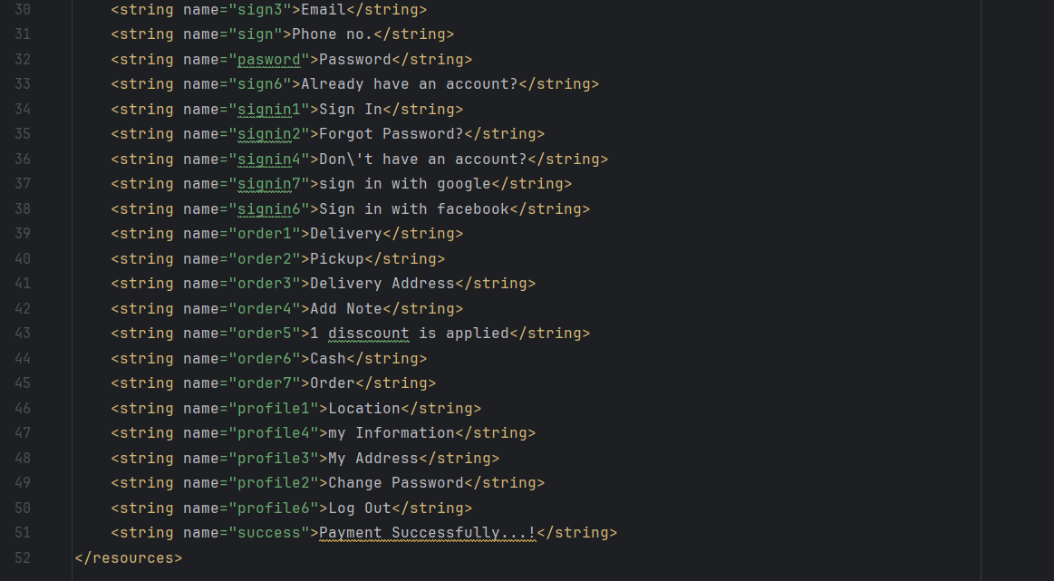

Colors

